World Café Tables - discussion highlights:

Getting started
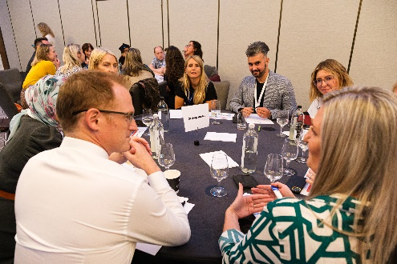
- Some pharmacists have found the research methods module delivered by CU very helpful.
- Protected time built into foundation training helps support research. Such protected time should be expanded to all pharmacist roles.
- Other HCPs (medics) may have more time built in for research – electives.
- Principal barrier to research is fear. But ethics approval is also challenging (perceived as inflexible).
- Everyone starts with a small first step, need to understand research = answering a question with data, could be a simple infographic, when published, there forever to inform others

Consultant credentialing
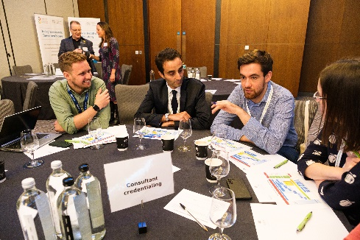
- Completing your portfolio for consultant credentialing (CP) should have a focus on demonstrating the impact on patients and the service when developing research
- The ability to complete the CP portfolio for the research domain can be completed by pharmacists with non-patient facing roles and options were discussed how to achieve this.
- Other tips for the CP portfolio were to complete the portfolio as you go along and to understanding it’s a development journey, not a portfolio to complete when you’ve done it all!
- Delegates were advised to look to colleagues to undertake research, as you don’t need to have to do all of the research on your own or do as part of an academic qualification
- Delegates were advised to consider undertaking research aligned with the PRW template structure for CP research progression, but had many questions around how to move between different sections of the algorithm such as how to move between Q1 and the audit sections.
- Delegates also asked how to leap from the research methods module to First into Research schemes and how this could be achieved within your career.
- Delegates discussed with facilitators how to link in with R&D departments, their Health Boards and relevant patient groups and to consider governance and accessibility of funding
- Delegates were advised that setting up research groups and advisory groups with lay representatives can also be used as evidence within the portfolio.
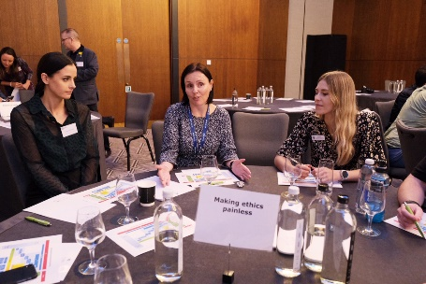
Making ethics painless
- It’s not as scary as you think and there is support out there.
- Talk to your R&D department, they can provide guidance
- Make sure you understand all requirements before submission by reading guidance carefully and seeking clarification if unsure.
- Include as much detail as possible in your application

How do we foster collaboration?
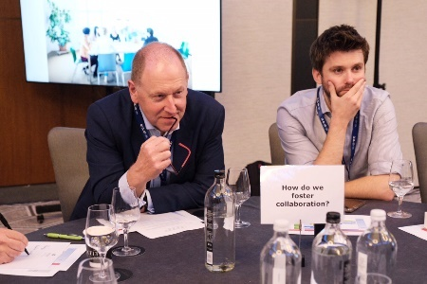
- Collaboration covers lots of levels – digital, operational, clinical – all are valuable
- Build research teams – need time release from delivering care to participate (all sectors) and requires cultural change from employers
- Time to network and explore – people feel in right place at right time, but that requires networking opportunities (conferences/ meetings) and time to attend/ explore collaboration and seek common ground on research goals.
- People in managerial roles – do they understand value? How are we enabling our own journeys and that of our colleagues in our teams? Shared responsibility?
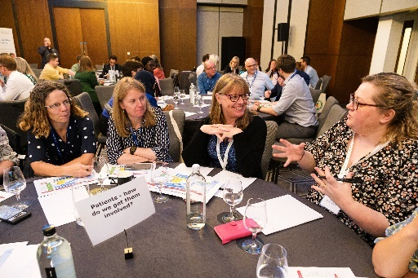
Patients – how do we get them involved
- How to recruit patients to engage with your research:
  - Identify target patient groups
  - Collaborate with healthcare providers and other health Boards to increase sample size
  - Leverage patient advocacy networks
  - Utilise social media and online platforms
  - Partner with patient registries or databases
  - Use targeted advertising to recruit patients
  - Offer incentives and benefits to encourage patient engagement
  - Remember to ensure that your recruitment strategies are conducted ethically and follow all relevant regulations and guidelines. Consult with your R&D department asap to discuss research governance and ethical requirements!

- How to involve patients in your research:
- Establish a patient advisory panel: Recruit a diverse group of patients who are interested in participating in research. This panel can provide insights, suggestions, and feedback throughout the research process.
- Seek feedback from patients on issues of informed consent, privacy, and data sharing to ensure research is conducted ethically and in a manner that respects patient rights.
- Conduct patient surveys or interviews to gather their perspectives and experiences on pharmacy-related issues.
- Share research findings with patients in a user-friendly and accessible format, such as through patient-friendly summaries or infographics.
- Invite patients to participate in focus groups or advisory boards to provide input and feedback on research design and priorities.
- Involve patients in the identification and prioritization of research topics by soliciting their suggestions and preferences.
- Collaborate with patient advocacy groups or patient organisations to engage patients in research planning and implementation.
- Develop patient-centred research questions and outcomes that align with patients' needs and goals.
- Disseminate research findings to patients through community events, newsletters, or online platforms, and encourage their active engagement and interpretation of the results.
- Remember, it is important to clearly communicate the purpose, potential risks, benefits, and expectations of participation to potential patients.

Where to find support and funding
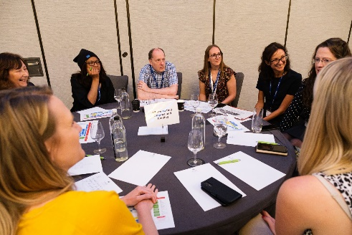
- Don’t have to do research on own – there are buddying and mentorship programmes together with talking to colleagues and collaborators.
- Magic money tree would solve our problems but meanwhile look out for funding opportunities through networks and social media.
- Look at Health and Care Research Wales website

